**Introduction to robotics HW#1**

(chapter 2)

기계로봇에너지공학과

2016110576 강재원

**2.5** The following frame *B* was moved a distance of *d* = (5, 2, 6)T. Find the new location of the frame relative to the reference frame.

U*B* = U*T*R ∙ R*B* = Trans(5, 2, 6)∙ R*B*

thus, R*B* = Trans(5, 2, 6)-1 ∙ U*B*

by the following MATLAB code,

uB = [0 1 0 2;1 0 0 4;0 0 -1 6;0 0 0 1];

uTr = [1 0 0 5;0 1 0 2; 0 0 1 6;0 0 0 1];

rB = inv(uTr) * uB

**R**

**2.13** Find the new location of point *P*(1, 2, 3)T relative to the reference frame after a rotation of 30° about the z-axis followed by a rotation of 60° about the y-axis.

new*P* = Rot( y, 60°) ∙ Rot( z, 30°) ∙ P

by the following MATLAB code,

P = [1;2;3;1];

newP = [cos(pi/3) -sin(pi/3) 0 0;sin(pi/3) cos(pi/3) 0 0;0 0 1 0;0 0 0 1] * [ cos(pi/6) 0 sin(pi/6) ggggggggg0;0 1 0 0;-sin(pi/6) 0 cos(pi/6) 0;0 0 0 1] * P

***P* = (-0.5490, 3.0490, 2.0981)**

**2.15** A point *P* in space is defined as *BP* = (2, 3, 5)T relative to frame *B* which is attached to the origin of the reference frame *A* and is parallel to it. Apply the following transformations to frame B and find *AP*. Using the 3-D grid, plot the transformations and the result and verify it:

● Rotate 90° about x-axis, then

● Rotate 90° about local a-axis, then

● Translate 3 units about y-, 6 units about z-, and 5 units about x-axis.

*AP* = Trans(5, 3, 6) ∙ Rot( x, 90°) ∙ Rot( z, 90°) ∙ *BP*

by the following MATLAB code,

BP = [2;3;5;1]

AP = [1 0 0 5;0 1 0 3;0 0 1 6;0 0 0 1] * [1 0 0 0;0 cos(pi/2) -sin(pi/2) 0;0 sin(pi/2) cos(pi/2) hhhhhhhhhhhhhh0;0 0 0 1] * [cos(pi/2) -sin(pi/2) 0 0;sin(pi/2) cos(pi/2) 0 0;0 0 1 0;0 0 0 1] * BP

***AP* = (2, -2, 8)**

**2.24** Suppose that a robot is made of a Cartesian and Euler combination of joints. Find the necessary Euler angles to achieve the following:

T1 = Rot(a, ψ) ∙ Rot(o, θ) ∙ Rot(a, φ)

= Rot(z, φ) ∙ Rot(y, θ) ∙ Rot(z, ψ)

by following MATLAB code,

syms phi theta psi

T1 = [cos(phi) -sin(phi) 0 0;sin(phi) cos(phi) 0 0;0 0 1 0;0 0 0 1]*[1 0 0 0;0 cos(theta) -sin(theta) 0;0 sin(theta) cos(theta) 0;0 0 0 1]*[cos(psi) -sin(psi) 0 0;sin(psi) cos(psi) 0 0;0 0 1 0;0 0 0 1]

T1 =

To find φ, θ, ψ, we need to find out $\tan{φ}, \tan{θ}, \tan{ψ}$ (because it have only one answer in its cycle)

$$\tan{φ}=2\left(\frac{a_{y}}{a_{x}}\right), \tan{θ}=2(\frac{a_{z}}{a_{x}\cos{φ}-a_{y}\sin{φ}}), tan{ψ}=2(\frac{o_{y}\cos{φ}-o_{x}\sin{φ}}{n_{y}\cos{φ}-n_{x}\sin{φ}})$$

thus, by using inverse triangulation function,

**Euler angle(φ, θ, ψ) = (0.9499, -1.4579, $1.059$ 0) (rad)**

**2.36** For the given specialty designed 4-DOF robot:

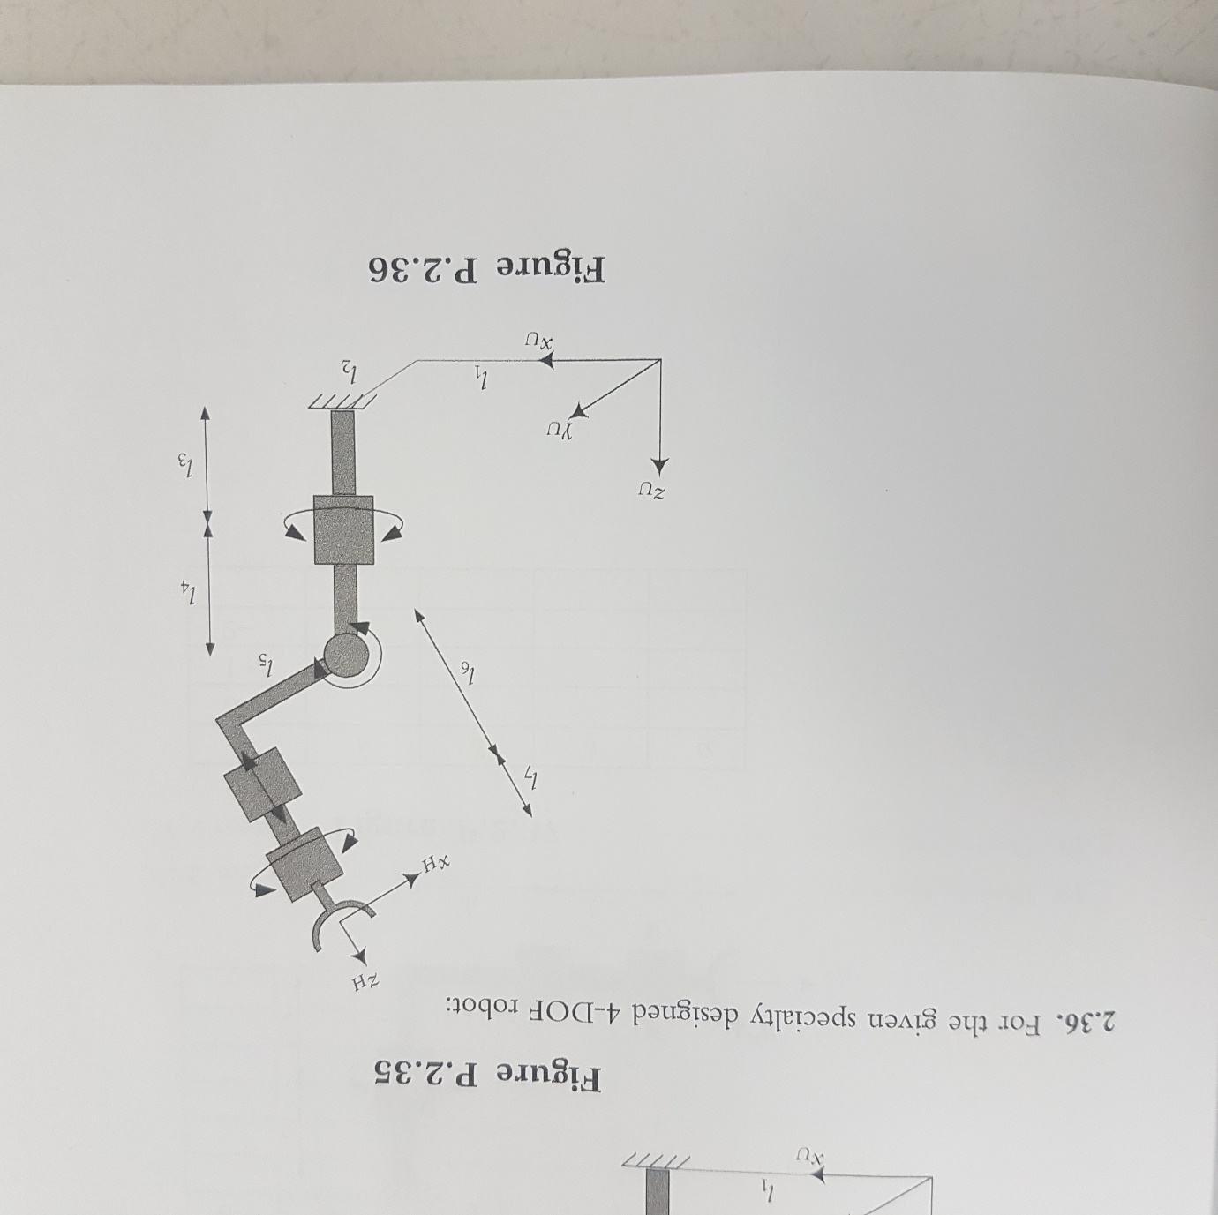

**X3**

**X2**

**X1**

**X0**

**Z3**

**Z2**

**Z1**

**Z0**

● Assign appropriate frames for the Denavit-Hartenberg representation.

● Fill out the parameters table.

|  |  |  |  |  |
| --- | --- | --- | --- | --- |
| # | θ | d | a | α |
| 0 - 1 | θ1 | l4 | 0 | π/2 |
| 1 - 2 | θ2+π | 0 | -l5 | π/2 |
| 2 - 3 | 0 | l6 | 0 | 0 |
| 3 – H | θ3 | l7 | 0 | 0 |

● Write an equation in terms of *A* matrics that shows how UTH can be calculated.

A = UTH = UT0 ∙ 0T1 ∙ 1T2 ∙ 2T3 ∙ 3TH

by the following MATLAB codes,

**DH_parameter.m**

function A = DH_parameter(theta, d, a, alpha)

% cos(pi/2)가 정확히 0이 아닌 문제를 해결하기 위해, degree로 변환시켜 계산한다.

% 입력 값들은 모두 실수(rad)이다.

dtheta = rad2deg(theta);

dalpha = rad2deg(alpha);

A = [cosd(dtheta) -sind(dtheta) 0 0;sind(dtheta) cosd(dtheta) 0 0;

0 0 1 0;0 0 0 1]*[1 0 0 0;0 1 0 0;0 0 1 d;0 0 0 1]*[1 0 0 a;

0 1 0 0;0 0 1 0;0 0 0 1]*[1 0 0 0;0 cosd(dalpha) -sind(dalpha) 0;

0 sind(dalpha) cosd(dalpha) 0;0 0 0 1];

**Q2_36_finding_A.m**

syms q1 q2 q3 l1 l2 l3 l4 l5 l6 l7;

A = [1 0 0 l1;0 1 0 l2;0 0 1 l3;0 0 0 1]*DH_parameter(q1,l4,0,pi/2)*DH_parameter(q2+pi,0, -l5,pi/2)*DH_parameter(0,l6,0,0)*DH_parameter(q3,l7,0,0)

$$A=$$

$$\begin{matrix}\sin{θ_{1}}\sin{θ_{3}}-\cos{θ_{1}}\cos{θ_{2}}\cos{θ_{3}} & \cos{θ_{3}}\sin{θ_{1}}+\cos{θ_{1}}\cos{θ_{2}}\sin{θ_{3}} & -\cos{θ_{1}}\sin{θ_{2}} & l_{1}+l_{5}\cos{θ_{1}}\cos{θ_{2}}-l_{6}\cos{θ_{1}}\sin{θ_{2}}-l_{7}\cos{θ_{1}}\sin{θ_{2}} \\ -\cos{θ_{1}}\sin{θ_{3}}-\cos{θ_{2}}\cos{θ_{3}}\sin{θ_{1}} & \cos{θ_{2}}\sin{θ_{1}}\sin{θ_{3}}-\cos{θ_{1}}\cos{θ_{3}} & -\sin{θ_{1}}\sin{θ_{2}} & l_{2}+l_{5}\cos{θ_{2}}\sin{θ_{1}}-l_{6}\sin{θ_{1}}\sin{θ_{2}}-l_{7}\sin{θ_{1}}\sin{θ_{2}} \\ -\cos{θ_{3}}\sin{θ_{2}} & \sin{θ_{2}}\sin{θ_{3}} & \cos{θ_{2}} & l_{3}+l_{4}+l_{6}\cos{θ_{2}}+l_{7}\cos{θ_{2}}+l_{5}\sin{θ_{2}} \\ 0 & 0 & 0 & 1\end{matrix}$$

**2.39** Derive the inverse kinematic equations for the robot of Problem 2.36.

*A* = UT0 ∙ 0T1 ∙ 1T2 ∙ 2T3 ∙ 3TH =

1T2 ∙ 2T3 ∙ 3TH = 0T1-1∙UT0-1 ∙

3TH =2T3-1 ∙ 1T2-1 ∙ 0T1-1∙UT0-1 ∙

by the following MATLAB code,

syms q1 q2 q3 l1 l2 l3 l4 l5 l6 l7 nx ny nz ox oy oz ax ay az Px Py Pz;

A = [1 0 0 l1;0 1 0 l2;0 0 1 l3;0 0 0 1]*DH_parameter(q1,l4,0,pi/2)*DH_parameter(q2+pi,0,-gdgdgl5,pi/2)*DH_parameter(0,l6,0,0)*DH_parameter(q3,l7,0,0);

ls = DH_parameter(q2+pi,0,-l5,pi/2)*DH_parameter(0,l6,0,0)*DH_parameter(q3,l7,0,0);

rs = inv(DH_parameter(q1,l4,0,pi/2))*inv([1 0 0 l1;0 1 0 l2;0 0 1 l3;0 0 0 1])*[nx ox ax Px;ny dkdkdkdkdkdkdoy ay Py;nz oz az Pz;0 0 0 1];

ls2 = DH_parameter(q3,l7,0,0)

rs2 = inv(DH_parameter(0,l6,0,0))*inv(DH_parameter(q2+pi,0,-l5,pi/2))*rs

by (3, 4) element of ls and rs,

$$P_{x}\sin{θ_{1}}-P_{y}\cos{θ_{1}}+l_{2}\cos{θ_{1}}-l_{1}\sin{θ_{1}}=0$$

$$\tan{θ_{1}}= \frac{P_{y}-l_{2}}{P_{x}-l_{1}}$$

by (2, 4) element of ls and rs,

$$l_{6}\cos{θ_{2}}-l_{7}\cos{θ_{2}}+l_{5}\sin{θ_{2}}= P_{z}-l_{3}-l_{4}$$

by (1, 1) and (2, 1) element of ls2 and rs2,

$\cos{θ_{3}}=-n_{x}\cos{θ_{1}}\cos{θ_{2}}+n_{y}\sin{θ_{1}}-n_{z}\sin{θ_{2}}$, $\sin{θ_{3}}=n_{x}\sin{θ_{1}}$

thus, $\tan{θ_{3}}=\frac{n_{x}\sin{θ_{1}}}{-n_{x}\cos{θ_{1}}\cos{θ_{2}}+n_{y}\sin{θ_{1}}-n_{z}\sin{θ_{2}}}$